## PROJECT – 1

**Project Name :** Creation of Single Page Website

**Task :** Create a Single Page Portfolio Website

## CONTENTS

* ABSTRACT
* OBJECTIVE
* INTRODUCTION
* METHODOLOGY
* CODE
* RESULT & OUTPUT
* CONCLUSION

## ABSTRACT

The creation of a single portfolio website involves the development of a personalized online platform for showcasing an individual's professional achievements, skills, and experiences. This project explores the design and implementation of a responsive, single-page portfolio website using a combination of HTML, CSS, JavaScript, and Bootstrap. The website's primary goal is to provide an easily accessible and visually appealing representation of the individual's work and qualifications. This website has some key components, that include a navigation menu, an about me section, an education section, a skills section, and contact information.

**OBJECTIVE**

The main objective of this single page portfolio website is to have a overview of a person’s full details. A person who wants to showcase his skills , knowledge and to describe about totally can use this method. This also helps to an employer to know the full details of a person or employee clearly and in a easy manner. The main objective of the portfolio website is to show case skills of a person , highlight skills , personal branding , build credibility, continuous improvement.

**INTRODUCTION**

Web development refers to the process of creating and maintaining websites and web applications for the internet or an intranet. It involves a combination of various skills, technologies, and methodologies to design, develop, and deploy functional and interactive web solutions. The web development is categorized as front-end development , back – end development and full-stack development . A portfolio website is a personal or professional website designed to showcase an individual's or a company's work, skills, achievements, and qualifications. It serves as an online platform for presenting a curated collection of projects, experiences, and other relevant information to potential employers, clients, collaborators, or a broader audience. This portfolio website contains the purpose, content, design and user experience, customization, navigation. This is done with the help of web development technologies i.e; **HTML , CSS, JAVASCRIPT , BOOTSTRAP** and **JQUERY** .

**HTML (Hyper Text Markup Language) :** HTML (Hypertext Markup Language) is the standard markup language used to create web pages and structure their content. It consists of a set of tags and elements that define the various components of a web page, such as headings, paragraphs, links, images, forms, and more. HTML plays a fundamental role in web development and is used in conjunction with CSS (Cascading Style Sheets) and JavaScript to create visually appealing, interactive, and responsive websites. It provides the structure and semantics needed to organize and present information on the internet, making it accessible to both humans and web browsers. HTML is one of the web development technology that is being used by all the people all over the world.

**CSS (Cascading Style Sheet) :** CSS (Cascading Style Sheets) is a language used for describing the presentation and styling of web documents written in HTML. It allows web developers to control the layout, appearance, and design of web pages, ensuring a consistent and visually appealing user experience across different devices and screen sizes. CSS achieves this by defining rules that specify how HTML elements should be displayed, including attributes like colors, fonts, spacing, positioning, and more. CSS is an essential part of modern web development, enabling the separation of content (HTML) from presentation (CSS), making websites easier to maintain, style, and adapt for various platforms and devices. It also plays a crucial role in enhancing user accessibility and optimizing page loading times.

**JS (Javascript) :** JavaScript is a versatile and widely-used programming language primarily used for adding interactivity and dynamic behavior to web pages. It allows developers to create responsive and feature-rich web applications by manipulating the content and behavior of websites in real-time within a user's web browser. JavaScript is an essential part of front-end web development, enabling actions like form validation, animations, real-time updates, and more. It can also be used in the back-end (Node.js) to build server-side applications. JavaScript is supported by all major web browsersand has a large ecosystem of libraries and frameworks, making it a powerful tool for creating modern web applications.

**BOOTSTRAP :** Bootstrap is a popular open-source front-end framework for web development that simplifies the process of designing and building responsive and visually appealing websites and web applications. Developed by Twitter, Bootstrap provides a collection of pre-designed HTML, CSS, and JavaScript components, such as navigation bars, buttons, forms, modals, and more. These components can be easily customized and integrated into web projects, saving developers time and effort. The features of bootstrap include Responsive design , Customization , Accessibility , Cross browser compatibility and Community and Ecosystem. Bootstrap simplifies front-end development by providing a well-documented and consistent set of tools and components, making it a valuable resource for both beginners and experienced web developers.

**METHODOLOGY**

In the process of creating this single page portfolio website , many steps have been involved. We will clearly see the steps now :

1. **Setting up the Tool :** the first step involved in the creatyion this single page portfolio website is deciding the tool and preparing the tool for usage. I used virtual studio code shortly known as VScode.
2. **Setting up XAMPP :**

* XAMPP is a free and open-source cross-platform web server solution stack package that consists mainly of the Apache HTTP Server, MariaDB database (MySQL replacement), and interpreters for scripts written in the PHP and Perl programming languages.
* Installation of XAMPP from the google in the apachefriends.org website and install it.

1. **Creating required files for the website :** A file is created in the XAMPP folder , that file consists of Bootstrap, CSS , JS and HTML.
2. **Creating the HTML page :** creating a html page in the VScode.
3. **Associating the CSS and JS :**

* Downloading the Bootstrap CSS and JS files from the Bootstrap official website and add file with the html page .
* Linking the CSS file and Bootstrap icons link which is copied from the Bootstrap website in the head section of the html page.
* Then, linking the JS file and JQuery link which is copied from the JQuery website in the body section with the script tag of the html page.

1. **Designing the webpage :** writing the code using HTML , CSS.
2. **Execution of the code :** Executing the written code in the html page and checking whether we got the required result or not.

**CODE**

**Index.html :**

<!DOCTYPE html>

<html lang="en">

<head>

<meta charset="UTF-8">

<meta name="viewport" content="width=device-width, initial-scale=1.0">

<meta name="description" content="simple portfolio website">

<meta name="keywords" content="HTML,portfolio website, Home,Education, About,Skills,Contact">

<title>single page portfolio website</title>

<link href="/bootstrap/css/bootstrap.css" rel="stylesheet">

<link href="index.css" rel="stylesheet">

<link rel="stylesheet" href="https://cdnjs.cloudflare.com/ajax/libs/bootstrap-icons/1.11.1/font/bootstrap-icons.min.css" integrity="sha512-oAvZuuYVzkcTc2dH5z1ZJup5OmSQ000qlfRvuoTTiyTBjwX1faoyearj8KdMq0LgsBTHMrRuMek7s+CxF8yE+w==" crossorigin="anonymous" referrerpolicy="no-referrer" />

</head>

<body>

<header>

<div id="name" >

<p><b> PONNAGANTI VAMSHI YOGEESHWAR</b></p>

<nav class="navbar">

<ul>

<li><a class="active" href="#home"><b>HOME</b></a></li>

<li><a href="#ABOUT"><b>ABOUT</b></a></li>

<li><a href="#EDUCATION"><b>EDUCATION</b></a></li>

<li><a href="#SKILLS"><b>SKILLS</b></a></li>

<li><a href="#CONTACT"><b>CONTACT</b></a></li>

</ul>

</nav>

</div>

</header>

<div class="mydiv" id="home">

<h3>Home</h3>

<p>Hi Everyone <br>My name is Ponnaganti Vamshi Yogeeshwar</p>

<img id="mypic" src="./images/pic1.png" alt="" width="330px" height="300px">

</div>

<div id="ABOUT" class="mydiv1">

<h3>About me</h3>

<p>

My name is Ponnaganti Vamshi Yogeeshwar studying in Mallareddy University of stream Information Technology

currently in III-year.<br>

Actually i am aiming to become a developer that may be front-end developer or back-end developer.<br>

For this aim, I am trying to develop my skills which may be either personal skills or technical skills.

<p><b style="color: red;">My Hobbies are : </b>cooking, Listening music, Exploring Tech</p>

<p><b style="color: red;">Email : </b>email@gmail.com</p>

<p><b style="color: red;">Contact : </b>+91 XXX-XXX-XXXX</p>

</p>

</div>

<div id="EDUCATION" class="mydiv2">

<h3>Education</h3>

<div class="flex">

<img id="edu" src="./images/edulogo.webp" alt="MallaReddy University" width="300px" height="150px">

<span> I am currently pursuing B.tech III-year in <a href="https://www.mallareddyuniversity.ac.in">MallaReddy

University</a> in Information Technology stream.</span>

</div>

<div class="flex">

<img id="edu1" src="./images/edulogo1.png" alt="Sri Chaitanya Junior Kalasala" width="300px" height="150px">

<span >I have completed my intermediate in <a href="https://srichaitanya.net">Sri Chaitanya Junior Kalasala</a>

in MPC stream.</span>

</div>

<div class="flex">

<img id="edu" src="./images/edulogo2.png" alt="Aurobindo Public School" width="300px" height="150px">

<span >I Completed my schooling in <a

href="https://school.careers360.com/schools/aurobindo-public-school-nalgonda">Aurobindo Public

School</a>.</span>

</div>

</div>

<div class="mydiv3" id="SKILLS" >

<h3>Skills</h3>

<div style="width:50%; height: 130px; float:left;">

<h4 >Personal Skills</h4>

<ul>

<li>Adapt to any situation immediately.</li>

<li>Good communication.</li>

<li>Interacting with everyone.</li>

</ul>

</div>

<div style="margin-left: 50%; height: 130px; " >

<h4 >Technical Skills</h4>

<ul>

<li>

<b>Front-end technologies :</b> HTML , CSS , Js , Bootstrap<br>

</li>

<li>

<p><b>Back-end technologies : </b>Java , Python </p>

</li>

</ul>

</div>

</div>

<div id="CONTACT" class="mydiv4">

<h3>Contact</h3>

<ul>

<li>

<p><b style="font-size:20px; ">Email : </b>email@gmail.com</p>

</li>

<li>

<p><b style="font-size:20px; ">Conatact : </b>+91 XXX-XXX-XXXX</p>

</li>

</ul>

</div>

<script src="https://code.jquery.com/jquery-3.7.1.js"

integrity="sha256-eKhayi8LEQwp4NKxN+CfCh+3qOVUtJn3QNZ0TciWLP4=" crossorigin="anonymous"></script>

<script src="https://cdnjs.cloudflare.com/ajax/libs/popper.js/2.9.2/umd/popper.min.js"

integrity="sha512-2rNj2KJ+D8s1ceNasTIex6z4HWyOnEYLVC3FigGOmyQCZc2eBXKgOxQmo3oKLHyfcj53uz4QMsRCWNbLd32Q1g=="

crossorigin="anonymous" referrerpolicy="no-referrer"></script>

<script src="/bootstrap/js/bootstrap.js"></script>

</body>

</html>

**Index.css :**

@import url('https://fonts.googleapis.com/css2?family=Poppins&display=swap');

html{

scroll-behavior: smooth;

}

*{

font-family: 'Poppins', sans-serif;

}

body {

margin: 0;

padding: 0;

}

#name {

background-color: #62959C;

color: white;

text-align: center;

padding: 10px;

display: flex;

justify-content: space-between;

}

#name > p{

color:white;

font-size: medium;

margin-left:50px ;

}

.navbar > ul{

display: flex;

gap: 15px;

}

.navbar > ul > li > a{

text-decoration:none;

color:white;

font-size: medium;

}

#Attributes ul {

list-style-type: none;

padding: 0;

}

#Attributes li {

margin-bottom: 10px;

}

#Attributes a {

text-decoration: none;

color: white;

font-weight: bold;

font-size: 18px;

}

#mypic {

display: block;

margin: 0 auto;

border-radius: 20px;

}

#about {

background-color: antiquewhite;

padding: 20px;

}

#about h4 {

color: #333;

}

#edu, #edu1 {

display: block;

margin: 0 auto;

}

#Skills {

padding: 10px;

}

#Skills h4 {

color: #333;

}

#get {

background-color: #333;

color: white;

text-align: lef;

padding: 20px 0;

}

.mydiv {

display:flex;

background-color: #606C5D;

padding: 10px;

border: 5px;

border-color: black;

align-items: center;

}

.mydiv > h3 {

text-align:top;

text-transform: uppercase;

font-size: 30px;

color: #001C30;

padding-bottom: 160px;

padding-left: 55px;

}

.mydiv > p {

padding: 50px;

font-size: 20px;

margin-left: 60px;

line-height: 200%;

}

.mydiv > div > img {

display: inline;

}

.mydiv1 {

background-color: #0802A3;

padding-left: 30px;

padding-top: 10px;

padding-bottom: 10px;

padding: 10px;

}

.mydiv1 > h3 {

font-size: 30px;

color: #FFFFFF;

padding-left: 55px;

text-transform: uppercase;

}

.mydiv1 > p {

color:floralwhite;

padding-left: 60px;

font-size: 20px;

}

.flex{

display: flex;

justify-content: center;

align-items: center;

padding: 10px;

}

.flex > img{

border-radius: 10px;

}

.flex > p{

width: 1000px;

display: flex;

}

.mydiv2{

padding: 10px;

font-size: medium;

background-color: #3CCF4E;

}

.mydiv2 > h3 {

padding-left: 55px;

font-size: 30px;

text-transform: uppercase;

}

.mydiv2 > div > img {

display:inline-flex;

align-items: first baseline;

}

.mydiv2 > div > span {

font-size: 20px;color: #952323;

}

.mydiv3{

padding: 10px;

background-color: #DDDDDD;

}

.mydiv3 > div > h4 {

color: #7D0633;

padding-left: 80px;

margin-bottom: 10px;

font-size: 30px;

}

.mydiv3 >div > ul > li {

font-size: medium;

padding-left: 40px;

}

.mydiv3 > h3 {

padding-left: 55px;

font-size: 30px;

margin: auto;

color: #C51605;

text-transform: uppercase;

}

.mydiv4{

background-color: #FFD89C;

padding: 20px;

}

.mydiv4 > h3 {

padding-left: 55px;

font-size: 30px;

padding-left: 30px;

text-transform: uppercase;

}

.mydiv4 > ul > li > p {

font-size: medium;

}

.navbar > ul > li{

list-style: none;

}

**RESULT & OUTPUT**

**1)**

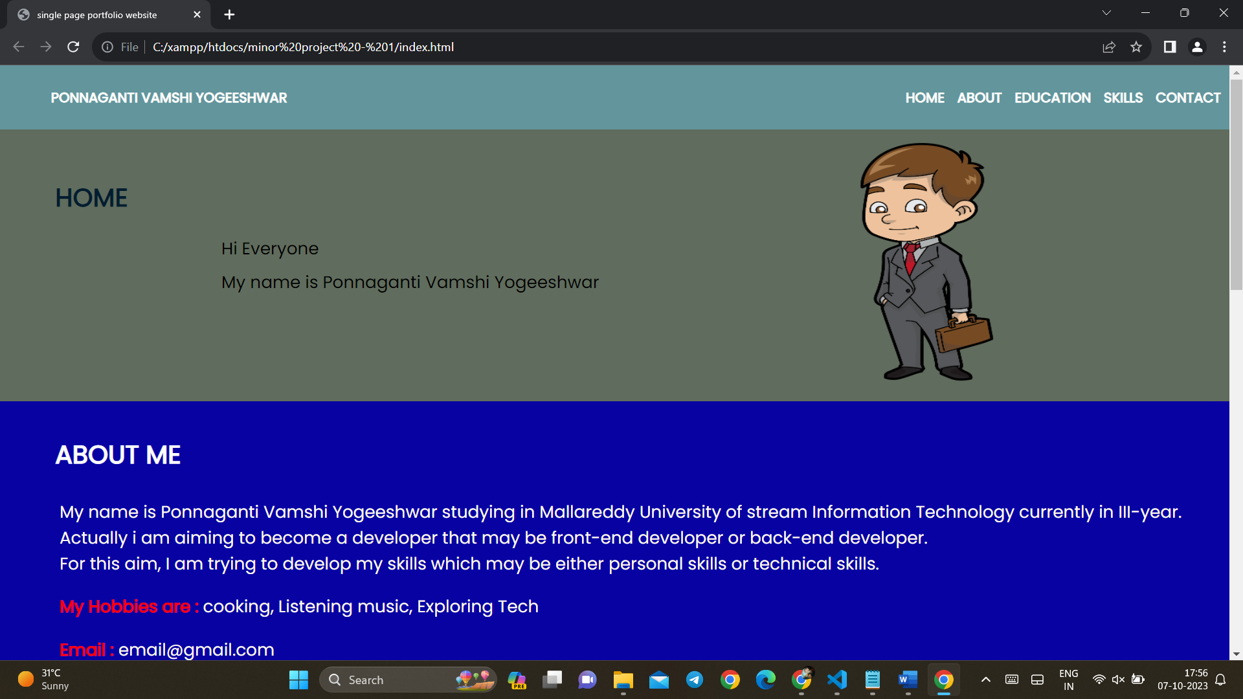

**2)**

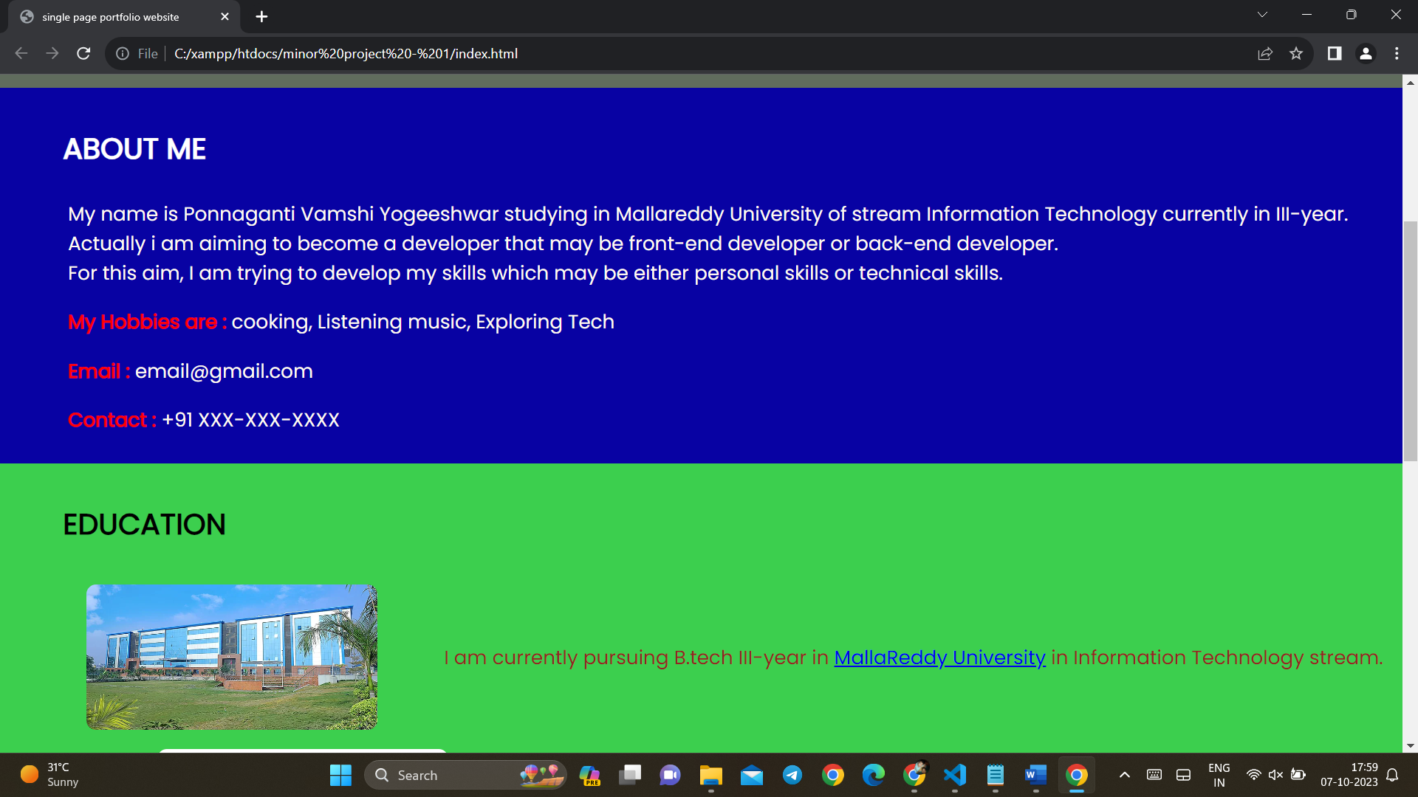

**3)**

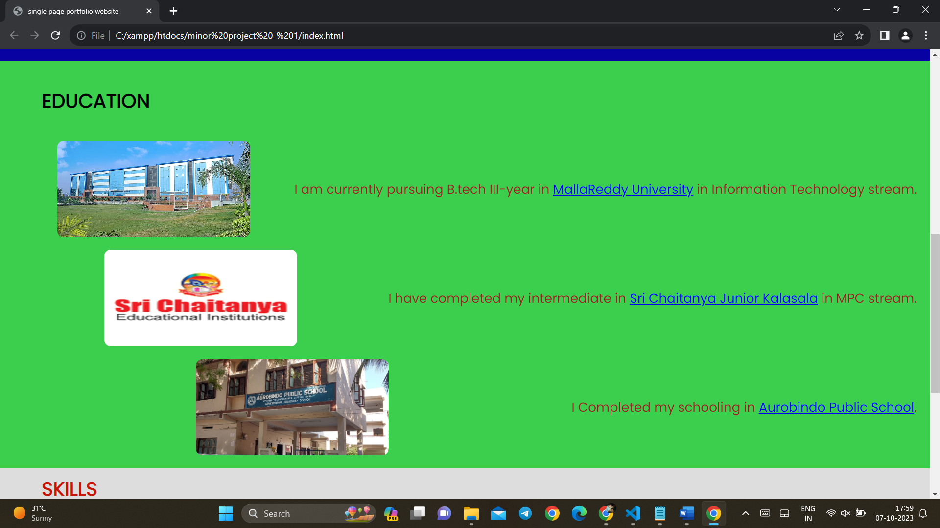

**4)**

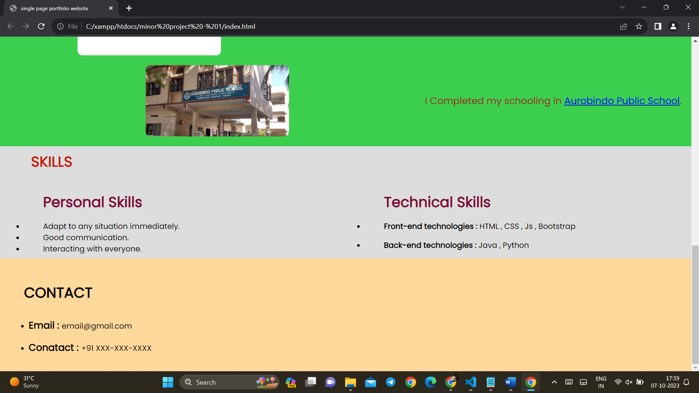

**CONCLUSION**

In conclusion, a portfolio website is a powerful tool for individuals and businesses alike to showcase their skills, work, and achievements to a global audience. It serves as a dynamic platform for creating a strong online presence, enhancing professional opportunities, and communicating expertise effectively. a well-constructed portfolio website becomes an invaluable tool for personal and professional growth, enabling individuals and businesses to connect with opportunities, partners, and audiences worldwide. In the digital age, a compelling online presence through a portfolio website is a cornerstone of success in various fields, including design, development, entrepreneurship, and more.